John James Hanna
May 18, 1853 – May 18, 1853

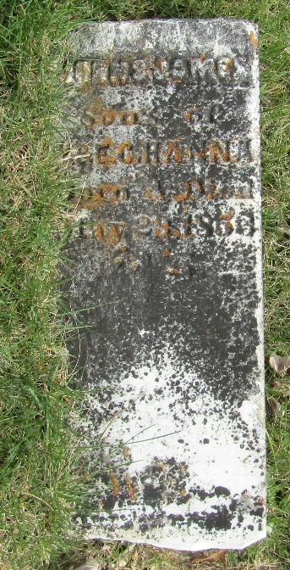

John Hanna from tree Hanna Family Tree

Birth 18 May or May 23, 1853 Wells, Indiana, USA
Death 18 May or May 23, 1853 Wells, Indiana, USA
Father William Hanna (1817-1873)
Mother Eliza Caroline Riddle (1817-1876)

