Hervey Hanna
May 21, 1859 – June 10, 1861

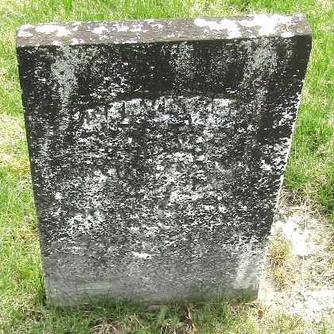

Harvey Hilton Hanna from tree MacLellan Family Tree
Birth 21 May 1859 Wells, Indiana, USA
Death 10 Jun 1861
Father William Hanna (1817-1873)
Mother Eliza Caroline Riddle (1817-1876)

