George K. Hanna
- May 13, 1874

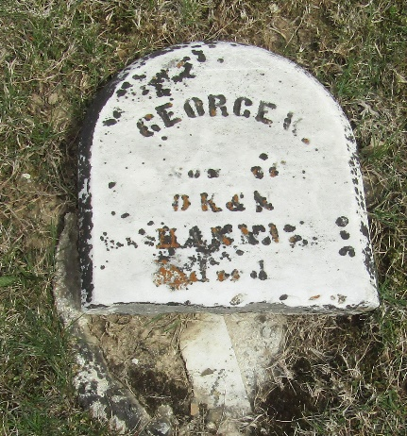

No further information found at this time

