Elisa Caroline (Riddell) Hanna
October 5, 1817 – March 26, 1876

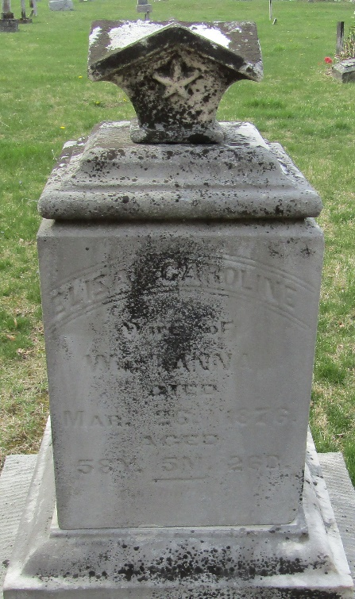

Eliza Caroline Riddell from tree Ridley Family Tree
Birth 5 Oct 1817 Ohio, USA
Marriage 25 Nov 1845 Wells, Indiana, USA
Residence 1870 Wells, Indiana, USA
Death 26 Mar 1876 Wells, Indiana, USA
Father James Riddell (1790-1854)
Mother Jane Bell (1797-1843)
Spouse William Hanna (1817-1873)

