Daniel Kirkpatrick Hanna
December 13, 1822 – January 13, 1899

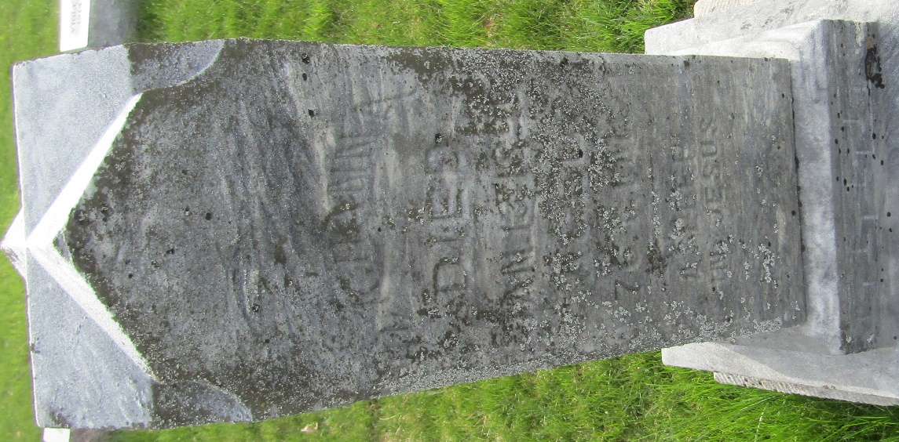

Daniel Kirkpatrick Hanna from tree Nutter Family Tree
Birth 13 Dec 1822 Pennsylvania, USA
Residence 1870 Wells, Indiana, USA
Death 13 Jan 1899 Wells, Indiana, USA
Father William JA Hanna
Mother Elizabeth
Spouse Nancy Law (1823-1917)

