Emily (Caroll) Hall
1825 - 1876

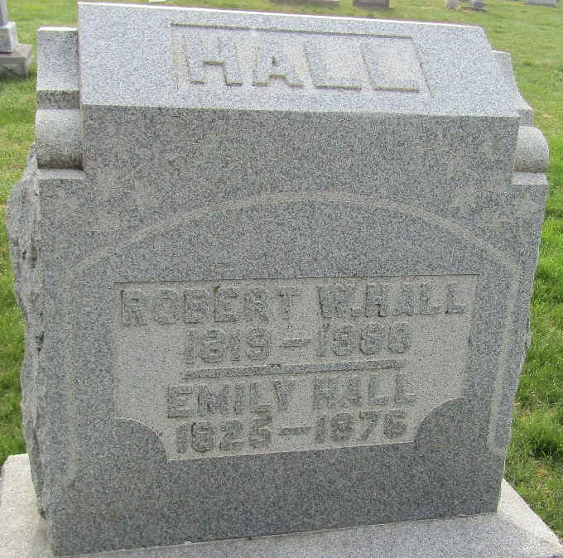

Emily Caroll from tree Kirk Family Tree
Birth 1825 New Jersey, USA
Marriage 22 Apr 1847 Cumberland, New Jersey, USA
Residence 1870 Wells, Indiana, USA
Death 1876 Wells Co. IN
Spouse Robert W. Hall (1819-1880)

