Mary E. (Cagle) Hale
November 20, 1922 – April 11, 2007

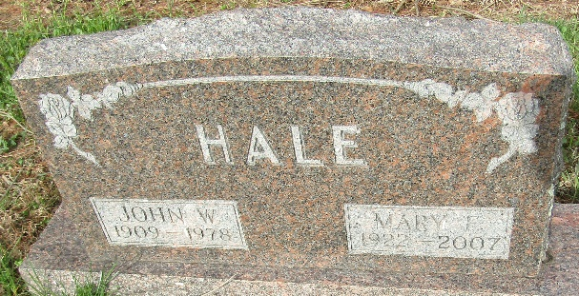

Mary E. Hale, 84, formerly of Bluffton died at 7:25 a.m. on Wednesday, April 11, 2007 at Ossian Healthcare. She had worked at Franklin Electric, Kitco, and in the kitchen at Caylor-Nickel Hospital.
She was born in Varnell, Ga. on Nov. 20, 1922, a daughter of James A. and Georgia (Bledshaw) Cagle. She was married on Dec. 1, 1945 in Arenton, Mo., to John W. Hale, who preceded her in death on May 5, 1978.
She is survived by her brother William J. Cagle of Granite City, Ill., along with her sisters Aldine Webb of Bluffton and Clara (Jack) Cole of Lakeland, Fla. She was preceded in death by her brother Clayton E. Cagle.
Visitation will be on Saturday from 2 to 8 p.m. at the Goodwin Memorial Chapel. Services will be on Sunday at 2 p.m. at the funeral home with Pastor Donald Marlowe officiating. Burial will be in Murray Cemetery.
Memorials may be made to the family.

Bluffton News-Banner, Wells County, Indiana
Thursday, April 12, 2007

