John Washington Hale
March 27, 1909 – May 5, 1978

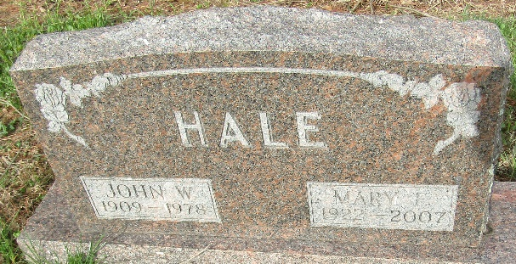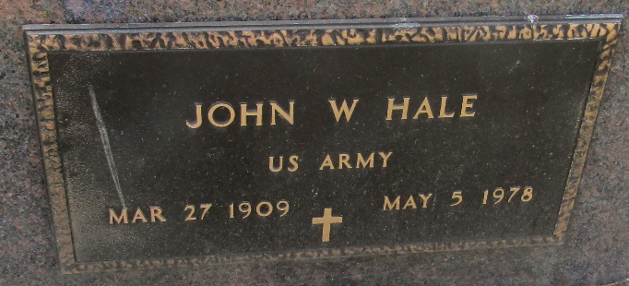

John Washington Hale
in the Indiana, U.S., Death Certificates, 1899-2017
Name John Washington Hale
Gender Male
Race Caucasian (White)
Marital Status Married
Age 69
Birth Date 27 Mar 1909
Birth Place Missouri
Death Date 5 May 1978
Death Place Indianapolis, Marion, Indiana, USA
Death Registration Date 1978
Father George Hale
Mother Mollie Abrahms
Spouse Mary E Cagle
Informant VA Hospital records; Indianapolis, Indiana
Burial May 8, 1978; Murray Cemetery; Bluffton, Indiana

