Ezra Gonyer
February 16, 1876 – August 1, 1949

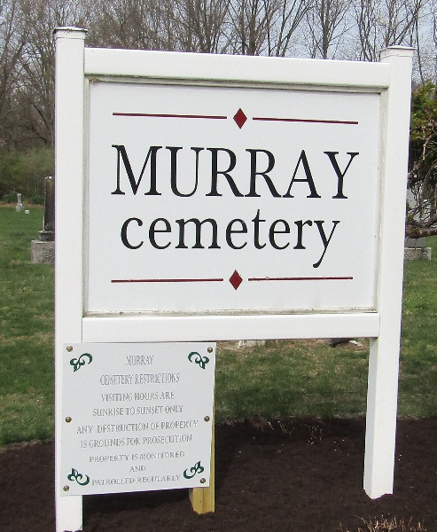

Ezra Gonyer
in the Indiana, U.S., Death Certificates, 1899-2017
Name Ezra Gonyer
Gender Male
Race White
Marital Status Married
Age 73
Birth Date 16 Feb 1876
Birth Place Michigan
Death Date 1 Aug 1949
Death Place Bluffton, Wells, Indiana, USA
Death Registration Date 1949
Father John Gonyer
Mother Unknown
Informant Mrs. Ezra Gonyer; Bluffton, Indiana
Burial August 3, 1949; Murray Cemetery; Wells County, Indiana

**
Ezra Gonyer from tree Johnson/Slater/Beardmore Family Tree
Record information.
Birth 16 Feb 1876 Ohio, USA
Residence 1880 Liberty, Wood, Ohio, USA
Death 1 Aug 1949
Record information.
Father Daniel Gonyer (1850-1917)
Record information.
Mother Anna Cecilia Bellcore (1855-1923)

