Mary Ann (Newcomb) Goliver
June 23, 1836 – March 29, 1870

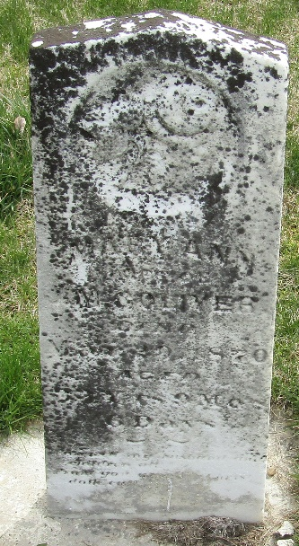

Mary Ann Newcomb from tree Gentry Family Tree
Birth 23 Jun 1836 Pleasant, Van Wert, Ohio, USA
Marriage 9 Feb 1854 Wells, Indiana, USA
Residence 1860 Wells, Indiana, USA
Death 29 Mar 1870 Wells, Indiana, USA
Father William Newcomb (1807-1850)
Mother Sarah Stevens (1813-1857)
Spouse James Madison Goliver (1827-1903)

