Rachel E. (Weller) Gleim
July 31, 1851 – March 18, 1910

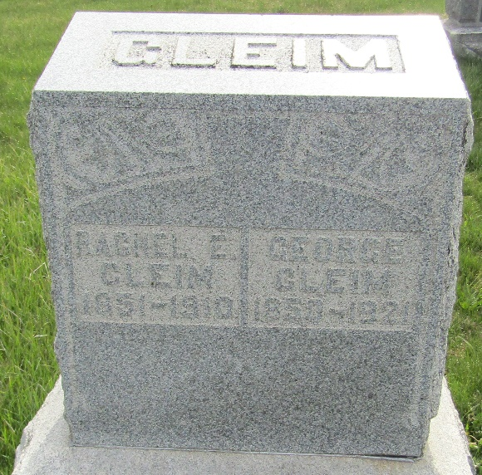

Rachel E Glesner
in the Indiana, U.S., Death Certificates, 1899-2017
Name Rachel E Gleim
[Rachel E Weller]
Gender Female
Race White
Marital Status Married
Age 58
Birth Date 31 Jul 1851
Birth Place Ohio
Death Date 18 Mar 1910
Death Place Lancaster, Wells, Indiana, USA
Death Registration Date 1910
Father Henry Weller
Mother Jane Ervin
Spouse George Gleim
Informant George Gleim; Bluffton, Indiana
Burial March 20, 1910; Murray Cemetery

