Oscar Henry Gleim
February 10, 1875 – February 20, 1944

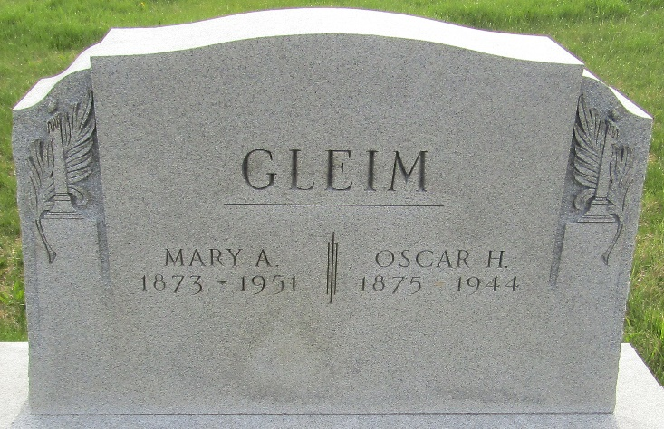

Oscar Henry Gleim
in the Indiana, U.S., Death Certificates, 1899-2017
Name Oscar Henry Gleim
Gender Male
Race White
Marital Status Married
Age 69
Birth Date 10 Feb 1875
Birth Place Ohio
Death Date 20 Feb 1944
Death Place Rural, Wells, Indiana, USA
Death Registration Date 1944
Father George Gleim
Mother Rachael Weller
Spouse Mary Agnes; age 70
Informant Mrs. Oscar Gleim; Bluffton, Indiana
Burial February 22, 1944; Murray Cemetery; Murray, Indiana

