Mary A. (McIntire) Gleim
October 13, 1873 – May 30, 1951

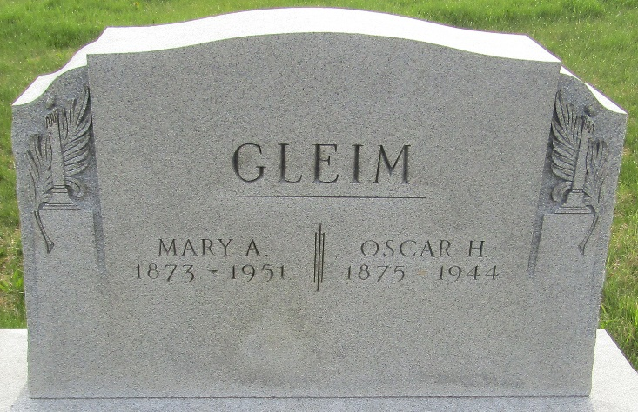

Mary A Gleim
in the Indiana, U.S., Death Certificates, 1899-2017
Name Mary A Gleim
Gender Female
Race White
Marital Status Widowed
Age 77
Birth Date 13 Oct 1873
Birth Place Jackson Twp Wells County
Death Date 30 May 1951
Death Place Bluffton, Wells, Indiana, USA
Death Registration Date 1951
Father Richard Mc Intire
Mother Mary K Hite
Informant Walter H. Gleim; Bluffton, Indiana
Burial June 2, 1951; Murray Cemetery; Murray, Indiana

