George Gleim
August 4, 1850 – September 28, 1921

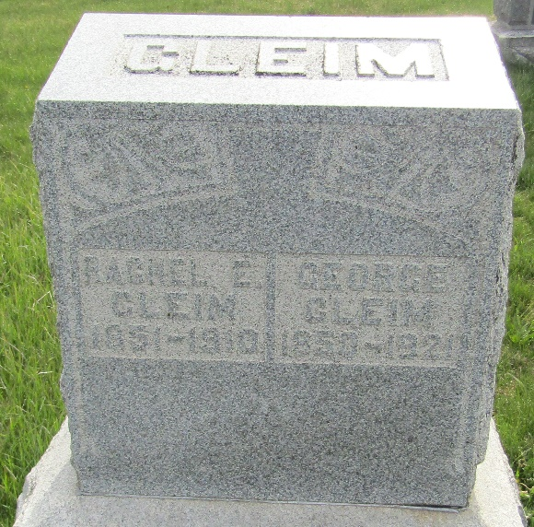

George Gleim
in the Indiana, U.S., Death Certificates, 1899-2017
Name George Gleim
Gender Male
Race White
Marital Status Widowed
Age 71
Birth Date 4 Aug 1850
Birth Place New York City
Death Date 28 Sep 1921; struck by auto
Death Place Bluffton, Vells, Indiana, USA
Death Registration Date 1921
Father George Gleim
Mother Mary Ridenour
Spouse Rachel Weller
Informant Oscar Gleim; Bluffton, Indiana
Burial September 30, 1921; Murray, Indiana

