Emory Warren Gleim
August 15, 1882 – September 7, 1948

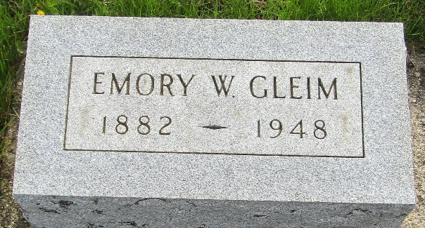

Emery Warren Gleim
in the Indiana, U.S., Death Certificates, 1899-2017
Name Emery Warren Gleim
Gender Male
Race White
Marital Status Single
Age 66
Birth Date 15 Aug 1882
Birth Place Blackford County, Indiana
Death Date 7 Sep 1948
Death Place Wells, Indiana, USA
Death Registration Date 1948
Father George Gleim
Mother Rachael Weller
Informant Walter Gleim; Bluffton, Indiana
Burial September 9, 1948; Murray Cemetery; Murray, Indiana

