Anna J. (Bennett) Glasgow
May 16, 1879 – April 22, 1908

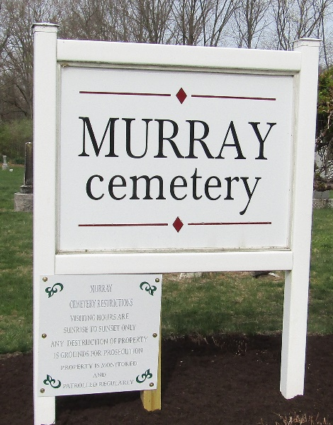

Anna J Glassgon
in the Indiana, U.S., Death Certificates, 1899-2017
Name Anna J Glassgow
[Anna J Bennett]
Gender Female
Race White
Marital Status
Age 28
Birth Date 16 May 1879
Birth Place Indiana
Death Date 22 Apr 1908
Death Place Portland, Jay, Indiana, USA
Death Registration Date 1908
Father John Bennett
Mother Elenor Park
Spouse James Glasgow
Informant James Glasgow; Portland, Indiana
Burial April 23, 1908; Murray Cemetery

