Roy R. Gilliom
July 21, 1894 – January 29, 1905

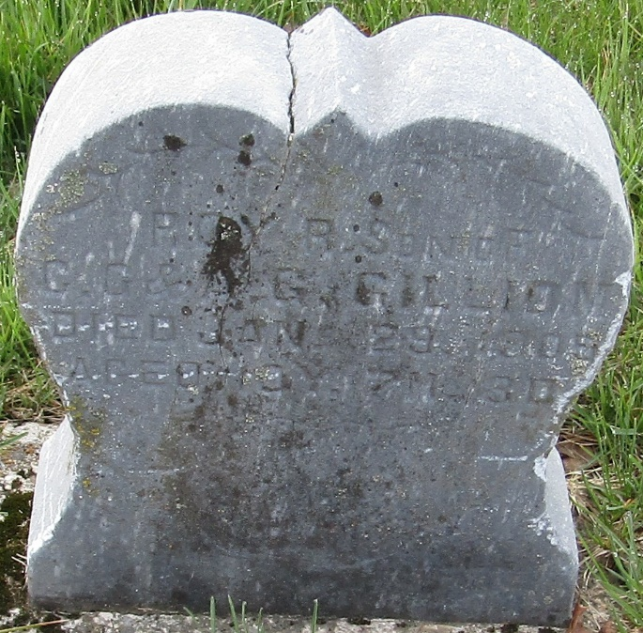

Roy Gilliom
in the Indiana, U.S., Death Certificates, 1899-2017
Name Roy Gilliom
Gender Male
Race White
Marital Status Single
Age 10
Birth Date 21 Jul 1894
Birth Place Indiana
Death Date 29 Jan 1905; pneumonia
Death Place Harrison, Wells, Indiana, USA
Death Registration Date 1905
Father Charls Gilliom
Mother Anna Neuenschwander
Informant Chas. Gilliom; Bluffton, Indiana
Burial January 31, 1905; Murray Cemetery

