Lydia H. (Kunkel) Gilliland
June 5, 1823 – February 4, 1897

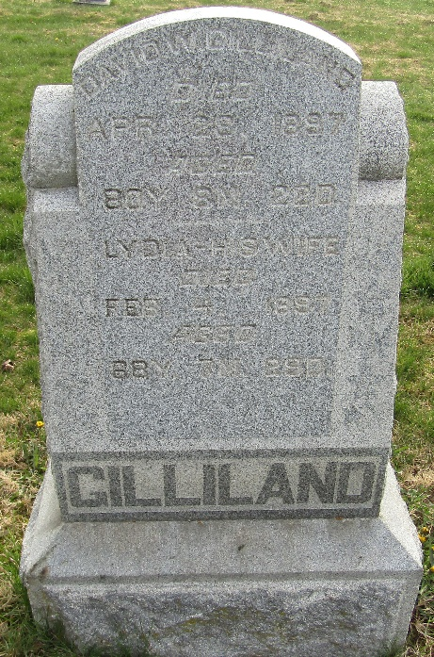

Lydia Kunkel from tree lorentz schuster less cosmos schuster(10)
Birth 5 Jun 1823 York, York, Pennsylvania, USA
Marriage 10 Jul 1845 Crawford, Coshocton, Ohio, USA
Residence 1880 Wells, Indiana, USA
Death 4 Feb 1897 Wells, Indiana, USA
Father Michael Kunkel (1784-1850)
Mother Anna Catherine Sentz (1791-1870)
Spouse David W Gilliland (1816-1897)

