David W. Gilliland
August 6, 1816 – April 28, 1897

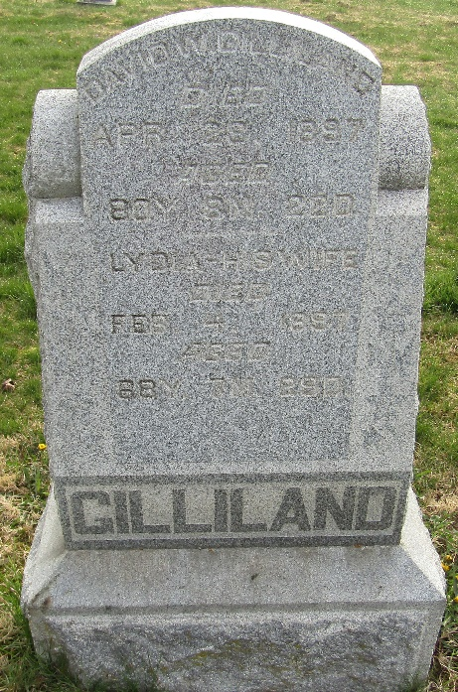

David H. Gilliland was born in Jefferson Co., Ohio, August 6th, 1816, died near Tocsin, Wells Co., Ind., April 28th, 1897. Aged 80 years, 8 months and 22 days. In 1845, he was married to Lidia Kunkle who preceded him to the Spirit World 2 months and 24 days. To this union were born six children, of whom two sons and three daughters are living. One sister and one brother, with a host of relatives and friends, are left to mourn but not without hope.
The deceased moved to Jefferson Township in an early day and underwent the hardships and privations incident to pioneer life. He was a good citizen and loved and respected by all who knew him.
He united with the United Brethren Church at the age of 30 years, of which he has been a faithful member for fifty years. He bore his last affliction with patience and resignation. The church has lost a good member, the community a respected citizen, the children a loving father.
The funeral services were held at the Tocsin church. His remains were laid to rest beside his companion in the Murray Cemetery.

Bluffton Chronicle; Wells County, Indiana
Wednesday, May 12, 1897

**
Ohio, U.S., County Marriage Records, 1774-1993
Name David W. Gilliland
Gender Male
Marriage Date 10 Jul 1845
Marriage Place Crawford, Ohio, USA
Spouse Lydia Kunkel
Film Number 000388675
**
David W Gilleland from tree Richard A. Corson Ancestry
Birth 6 Aug 1816 Jefferson, Ashtabula, Ohio, USA
Marriage 10 Jul 1845 Crawford, Ohio, USA
Residence 1880 Wells, Indiana, USA
Death 28 Apr 1897 Wells, Indiana, USA
Father William Gilliland (Born 1790)
Mother Catherine Welday (1796-1877)
Spouse Lydia Kunkle (1823-1897)

