Amos Gilliland
April 24, 1861 – May 10, 1864

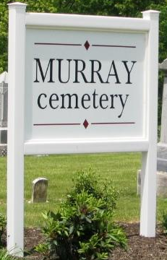

Amos C Gilliland from tree Reed Family Tree
Birth 24 Apr 1861 Indiana, USA
Residence 1860 Bluffton, Wells, Indiana, USA
Death 10 May 1864
Father David W Gilliland (1816-1897)
Mother Lydia Kunkel (1823-1897)

