Stephen T. Gilbert
February 12, 1849 – February 19, 1866

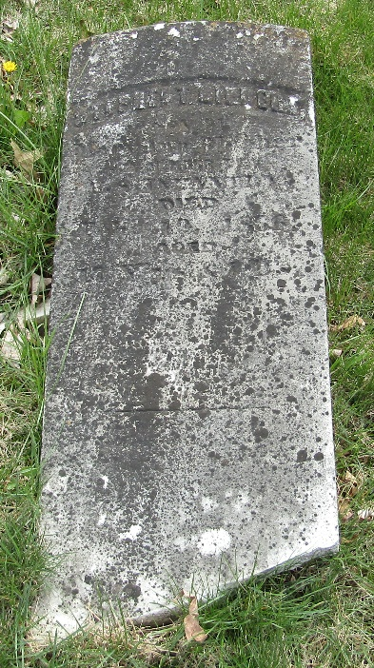

No further information found at this time

