Elizabeth (Gundrum) Gearheart
June 18, 1841 – February 16, 1920

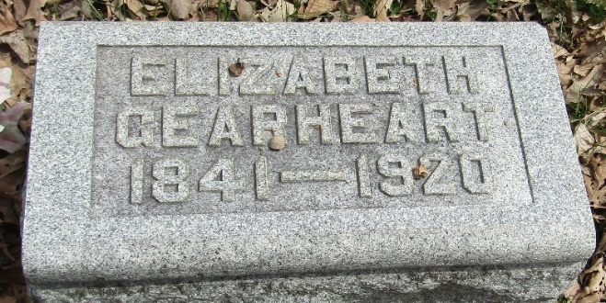

Elizabeth Gearhart
in the Indiana, U.S., Death Certificates, 1899-2017

Name Elizabeth Gearhart
Gender Female
Race White
Marital Status Widowed
Age 78
Birth Date 18 Jun 1841
Birth Place Lebanon Co ??
Death Date 16 Feb 1920
Death Place Fort Wayne, Allen, Indiana, USA
Death Registration Date 1920
Father Aaron Gundrun
Mother Unknown
Informant C. F. Tobias; Fort Wayne, Indiana
Burial February 18, 1920; Bluffton, Indiana
**
Elizabeth Gundrum from tree Traber
Birth Jun 1842 Pennsylvania, USA
Marriage 1859
Residence 1910 Wells, Indiana, USA
Death 16 Feb 1920
Father Henry Gundrum (1811-1887)
Mother Eve Stump (1809-1885)
Spouse William Gearhart (Born 1834)

