Minnie M. (Baber) Gaskill
August 16, 1881 – October 6, 1921

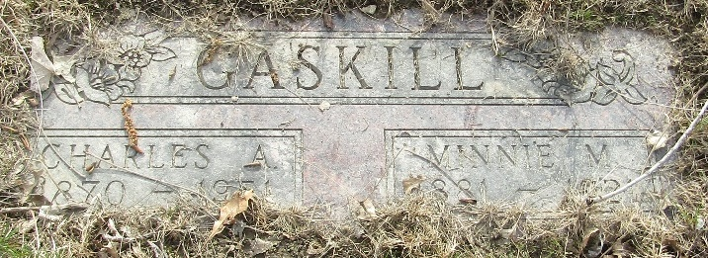

Minnie M Gaskill
in the Indiana, U.S., Death Certificates, 1899-2017
Name Minnie M Gaskill
[Minnie M Baber]
Gender Female
Race White
Marital Status Married
Age 40
Birth Date 16 Aug 1881
Birth Place Indiana
Death Date 6 Oct 1921
Death Place Wells, Indiana, USA
Death Registration Date 1922
Father William Baber
Mother Rachel Broadt
Spouse Chas Gaskill
Informant Chas. Gaskill; Uniondale, Indiana
Burial October 8, 1921; Murray Cemetery

