Charles Alvin Gaskill
February 13, 1870 – January 13, 1951

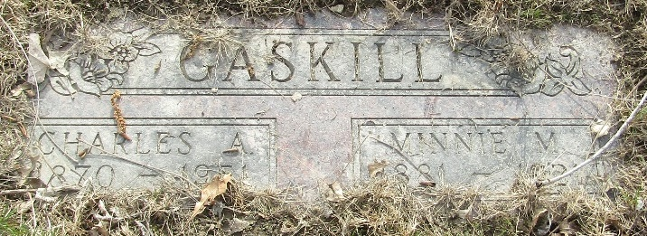

Charles A Gaskill
in the Indiana, U.S., Death Certificates, 1899-2017
Name Charles A Gaskill
Gender Male
Race White
Marital Status Widowed
Age 80
Birth Date 13 Feb 1870
Birth Place Indiana
Death Date 13 Jan 1951
Death Place Fort Wayne, Allen, Indiana, USA
Death Registration Date 1951
Father Gaskill
Mother Nothing stated
Informant Mrs. Wm. Lehman; Fort Wayne, Indiana
Burial January 16, 1951; Murray Cemetery; Wells County, Indiana

**
Indiana, U.S., Marriages, 1810-2001
Name Charles Alvin Gaskill
Gender Male
Race White
Age 36
Event Type Marriage Registration (Marriage)
Birth Date 18 Feb 1870
Birth Place Allen, Indiana
Marriage Date 5 Oct 1906
Marriage Place Indiana, United States
Residence Place Uniondale, Indiana
Father Isaac Gaskill
Mother Eliza N Chaney
Spouse Minnie May Baber
Page 185
FHL Film Number 002318673

