Thomas M. Garton
January 13, 1872 – June 13, 1878

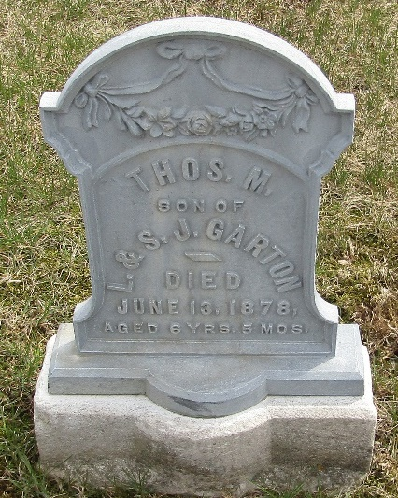

Thomas William Garton from tree Krueger/Garton/Harris/Jackson/Cook/Runyon
Birth 13 Jan 1872 Craigville, Wells, Indiana, USA
Death 13 Jan 1887 Craigville, Wells, Indiana, USA(sic)
Father Lawrence W Garton (1850-1911)
Mother Sarah Jane Ball Garton (1850-1890)

