Sarah Jane (Ball) Garton
September 8, 1850 – June 14, 1890

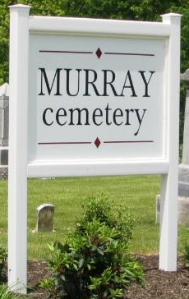

Sarah Jane Ball from tree Bowen/Shaw/Thompson/Griffin/Scott/Ramsey Family Tree
Birth 8 Sep 1850 Wells, Indiana, USA
Marriage 13 Apr 1871 Wells, Indiana, USA
Residence 1880 Liberty Center, Wells, Indiana, USA
Death 14 Jun 1890 Wells, Indiana, USA
Spouse Lawrence W. Garton (1850-1911)

