Paris D. Garton
November 25, 1848 – January 4, 1888

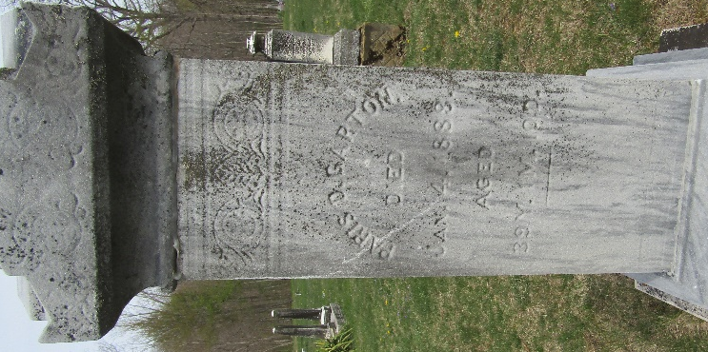

Paris D. Garton from tree Garton Tree, the James Owen line
Birth 25 Nov 1848 Wells, Indiana, USA
Marriage 18 Aug 1872 Wells, Indiana, USA
Residence 1880 Wells, Indiana, USA
Death 4 or 14 Jan 1888
Father Lewis Garton (1824-1915)
Mother Rachel Lyon (1825-1887)
Spouse Sarah E. Bryson (Born 1847)

