Mary Elizabeth (Trullender) Garton
May 28, 1836 – June 18, 1890

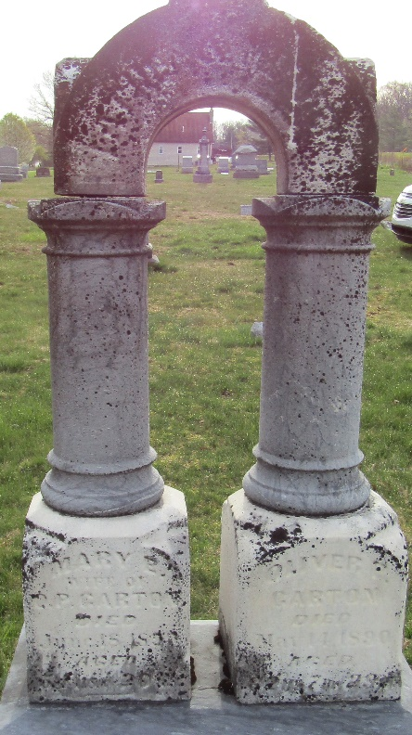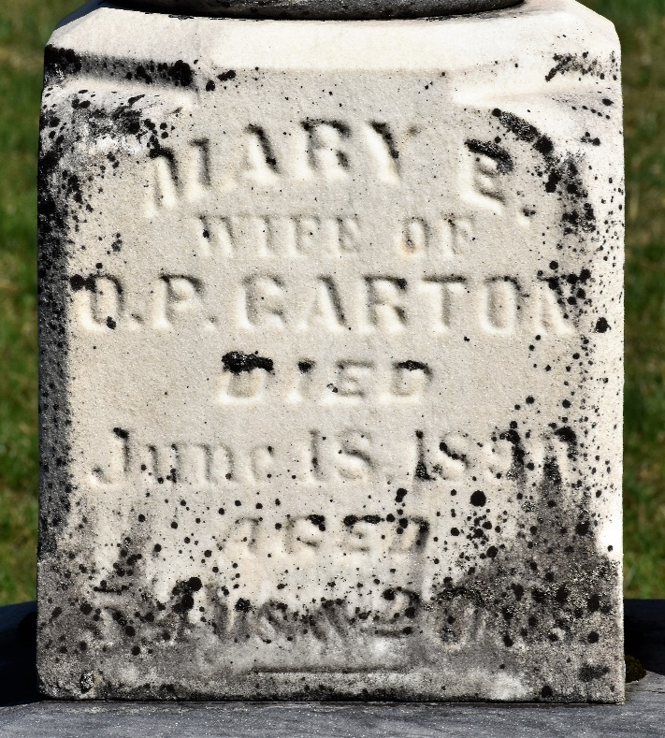

Mary Elizabeth Trullender from tree Garton and Bentley Family tree
Birth 28 May 1836 Franklin, Johnson, Indiana, USA
Marriage 7 Jul 1853 Wells, Indiana, USA
Residence 1880 Wells, Indiana, USA
Death 18 Jun 1890
Father Hiram Samuel Trullender (1804-1891)
Mother Ruth Dare High Trullender (1818-1890)
Spouse Oliver Perry Garton (1827-1890)

