Lyle Lawrence Garton
May 2, 1850 – February 12, 1911

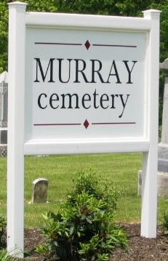

LYLE GARTON DIED SUNDAY NIGHT
Passed Away at the Home of his Son - Funeral was Tuesday

Lyle Garton, 60, passed away Monday night at the residence of his son, Frank, on Bond Street, where he has been in a very serious condition with lung trouble and complications.
Mr. Garton was born in Wells County on May 2, 1850, the son of Louis and Rachel Garton. His entire life was spent here. In 1870 he was married to Miss Sarah Jane Ball, who preceded him in death.
Mr. and Mrs. Garton were the parents of seven children, of whom only three survive. They are Frank and Louis, of this city, and Mrs. Stella Fast, of Fort Wayne. Mr. Garton is also survived by one brother and three sisters, as follows: John Garton, Lake City, Mich.; Mrs. William Kleinknight, Pugney; Mrs. Daniel Biddle, Lake City, Mich.; and Mrs. H. Hallug, Fort Wayne. His father, Louis Garton, Sr. also survives and makes his home at Lake City, Mich., with other children.
The funeral took place at the Christian Church on West Cherry Street an ten o'clock Tuesday morning. The burial was at Murray.

Bluffton Chronicle, Wells County, Indiana
February 15, 1911

