Henry Johnson Garton
January 28, 1835 – November 11, 1910

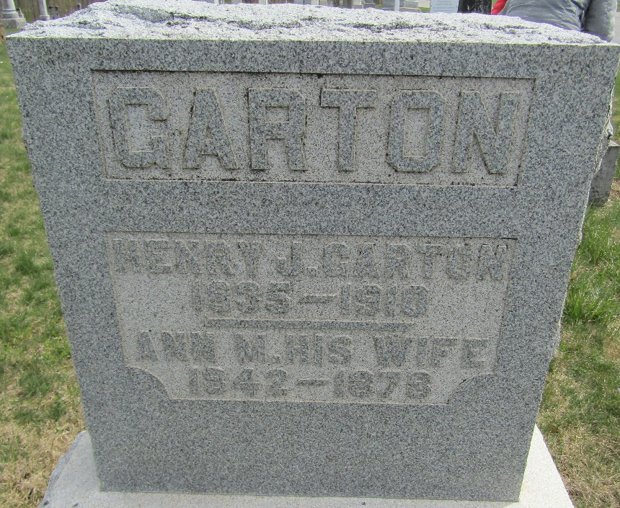

Henry Johnson Garton
in the Indiana, U.S., Death Certificates, 1899-2017
Name Henry Johnson Garton
Gender Male
Race White
Marital Status Widower
Age 75
Birth Date 28 Jan 1835
Birth Place New Jersey
Death Date 11 Nov 1910
Death Place Tocsin, Wells, Indiana, USA
Death Registration Date 1910
Father John Garton
Mother Elizabeth Sowder
Spouse Anna Emma Trullender
Informant Thomas J. Sowards; Tocsin, Indiana
Burial November 13, 1910; Murray Cemetery

