Anna Maria (Trullender) Garton
October 2, 1842 – July 31, 1878

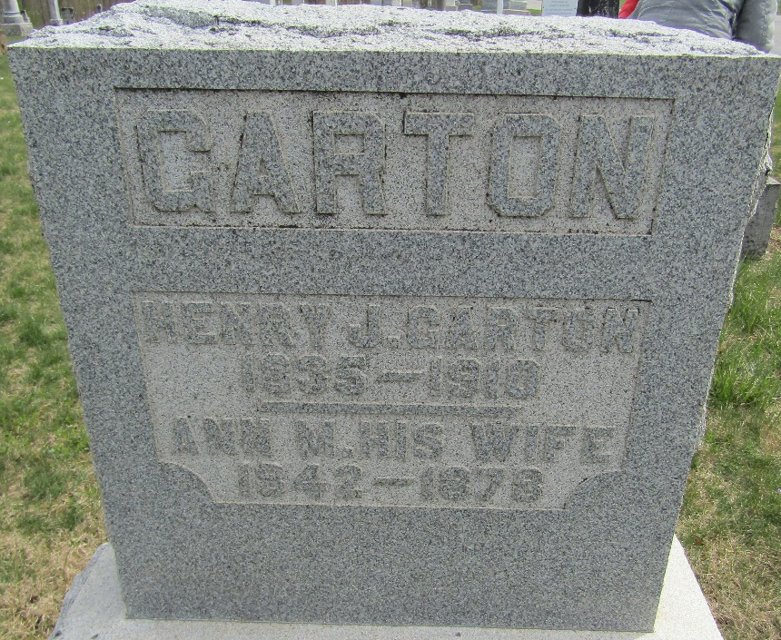

Anna Maria Trullender from tree Garton Tree, the James Owen line
Birth 2 Oct 1842 Indiana, USA
Marriage 5 Jan 1860 Wells, Indiana, USA
Residence 1870 Wells, Indiana, USA
Death 31 Jul 1878 Wells, Indiana, USA
Father Hiram Samuel Trullender (1805-1891)
Mother Ruth Dare High (1819-1890)
Spouse Henry Johnson Garton (1835-1910)

