Andrew Jackson Garton
August 19, 1832 – November 10, 1855

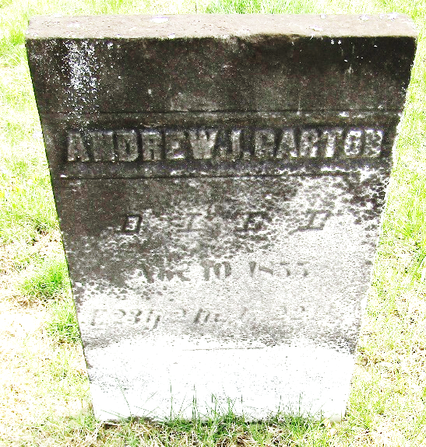

Andrew Jackson "Jack" Garton from tree Lee, Nash, Reed, Sowards, Strickler, Fohl, Shady, Dailey, Kemper Family Tree / Bolter, Draper Family Tree
Birth 19 Aug 1832 Cumberland, New Jersey, USA
Residence 1850 Wells, Indiana, USA
Death 10 Nov 1855 Wells, Indiana, USA
Father Jonathan GARTON (1796-1879)
Mother Elizabeth "Betsy" SOUDER (1796-1872)

