Adella Garton
July 10, 1864 – September 10, 1865

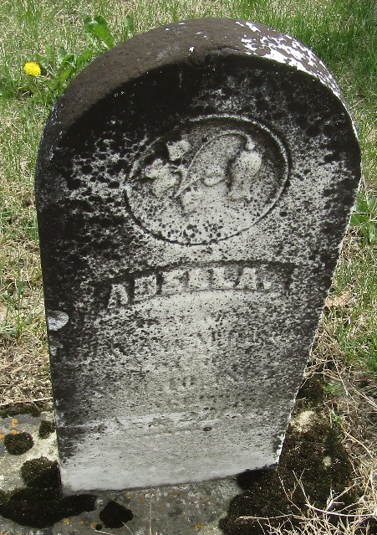

Adella Garton from tree Garton Tree, the James Owen line
Birth 10 Jul 1864
Death 10 Sep 1865
Father Henry Johnson Garton (1835-1910)
Mother Anna Maria Trullender (1842-1878)

