Thomas N. Galyean
August 25, 1856 – April 16, 1859

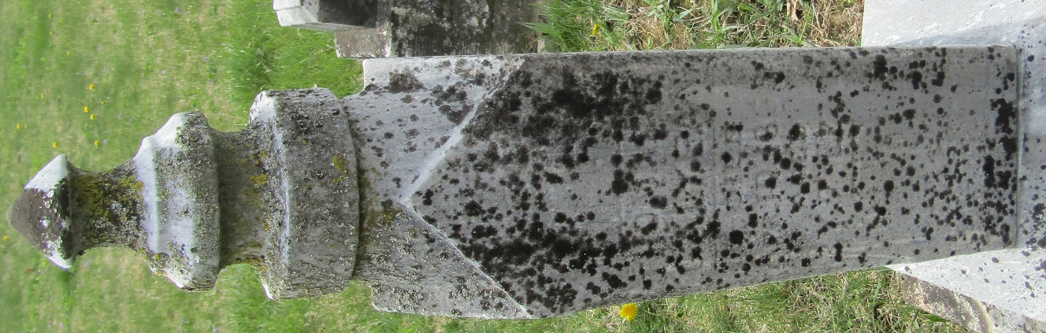

Thomas M. Gallion from tree Olsen

Birth 1871(sic) Wells, Indiana, USA
Father Samuel Harlan Galyean (1832-1889)
Mother Edith Ellis (1833-1906)

