Samuel Harlan Galyean, Sr.
May 13, 1832 – November 30, 1893

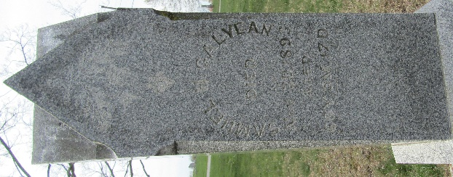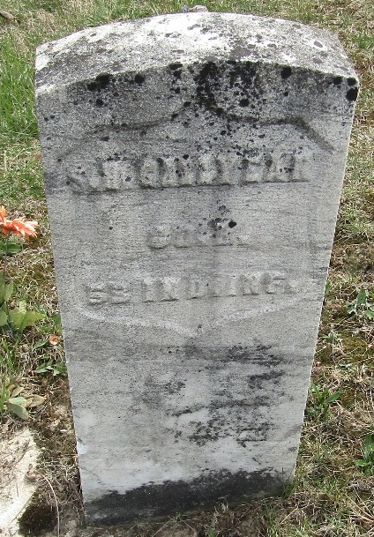

At an early hour last Thursday morning occurred the death of Samuel H. Galyean at the age of 61 years, 6 months and 17 days. His death was the result of a severe attack of pneumonia.
Mr. Galyean came with his father's family to Lancaster Township in 1842 and has been a resident of the county ever since. For the past two years he has resided in the city.
His family consisted of eight children, four of whom survive him.
Mr. Galyean was a soldier in the late war, being a member of the Fifty-Third Indiana Infantry.
His funeral occurred Sunday under the auspices of the G. A. R. His remains were taken to Murray for interment.

Bluffton Banner; Wells County, Indiana
Wednesday, December 6, 1893
**
Samuel Harlan Galyean from tree McMasters Family Tree
Birth 13 May 1832 Henry, Indiana, USA
Residence 1880 Wells, Indiana, USA
Death 30 Nov 1893 Wells, Indiana, USA
Father Thomas Gallien / Galyean (1787-1861)
Mother Tabitha Warren (1794-1839)
Spouse Edith Ellis (1833-1906)

