Samuel Harlan Galyean, Jr.
October 18, 1865 – November 3, 1889

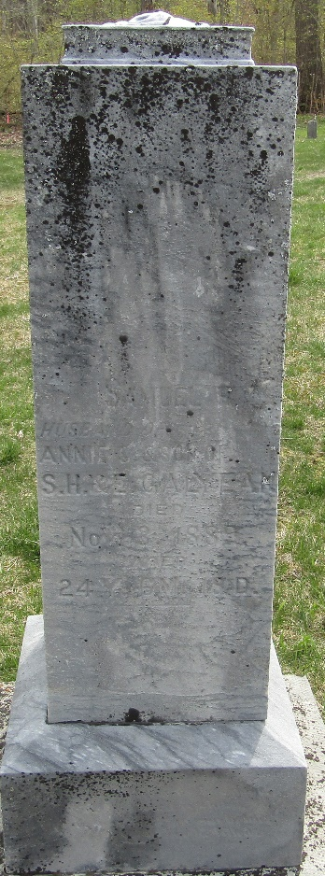

Samuel Harlan Galyean from tree Bolles/Kier Family Tree
Birth 18 Oct 1865 Bluffton, Wells, Indiana, USA
Residence 1880 Wells, Indiana, USA
Marriage 24 Mar 1887 Wells, Indiana, USA
Death 3 Nov 1889 Wells, Indiana, USA
Father Samuel Harlan Galyean (1833-1893)
Mother Edith Elizabeth Ellis (1833-1906)
Spouse Anna Catherine (Annie) Redding (1867-1914)

