Edith Elizabeth (Ellis) Galyean
September 23, 1833 – June 20, 1906

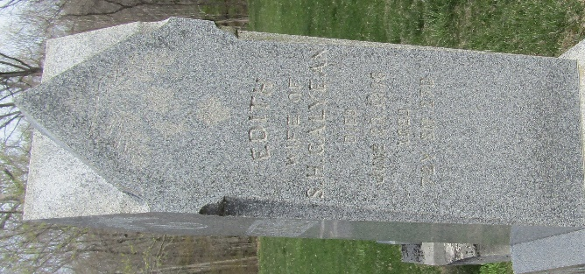

Edith Gallipean
in the Indiana, U.S., Death Certificates, 1899-2017
Name Edith Gallyean
[Edith Ellis]
Gender Female
Race White
Marital Status Widow
Age 72
Birth Date 23 Sep 1833
Birth Place Indiana
Death Date 20 Jun 1906
Death Place Bluffton, Wells, Indiana, USA
Death Registration Date 1906
Father Mortica Ellis
Mother Ruth Hinshaw
Spouse S H Galyean
Informant Family; Bluffton, Indiana
Burial June 22, 1906; Murray Cemetery

