Carrie Rachel Galyean
March 7, 1872 – October 26, 1888

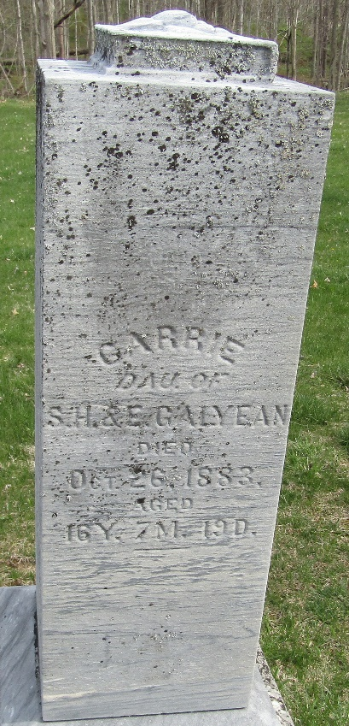

Carrie Rachel Galyean from tree O'Rourke Family Tree
Birth 1867 Bluffton, Wells, Indiana, USA
Residence 1880 Wells, Indiana, USA
Death 26 Oct 1888 Wells, Indiana, USA
Father Samuel Harland Galyean (1832-1893)
Mother Edith Elizabeth Ellis (1833-1906)

