Gifford Franklin Gallimore
April 2, 1912 – January 17, 1923

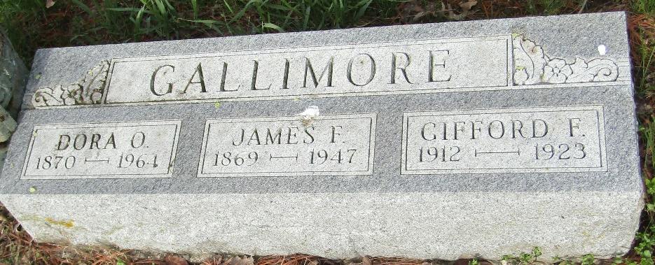

Gifford Franklin Gallinore
in the Indiana, U.S., Death Certificates, 1899-2017
Name Gifford Franklin Gallimore
Gender Male
Race White
Marital Status Single
Age 10
Birth Date 2 Apr 1912
Birth Place Tipton County, Indiana
Death Date 17 Jan 1923; accidental drowning
Death Place Lancaster, Wells, Indiana, USA
Death Registration Date 1923
Father Frank Gallimore
Mother Dora Perkins
Informant Frank Gallimore; Murray, Indiana
Burial January 19, 1923; Murray, Indiana

