Dora Alice (Perkins) Gallimore
June 11, 1870 – June 12, 1964

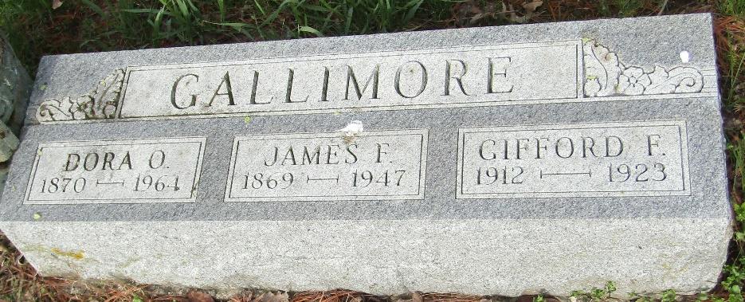

Dora Oleva Gallimore
in the Indiana, U.S., Death Certificates, 1899-2017
Name Dora Olive Gallimore
[Dora Olive Perkins]
Gender Female
Race White
Marital Status Widowed
Age 94
Birth Date 11 Jun 1870
Death Date 12 Jun 1964
Death Place Bluffton, Wells, Indiana, USA
Death Registration Date 1964
Father Ute Perkins
Mother Nancy
Informant Mrs. William Gilliom; daughter; Bluffton, Indiana
Burial June 14, 1964; Murray Cemetery; Bluffton, Indiana

