Sarah (Egbert) Fulton
February 24, 1817 – March 8, 1864

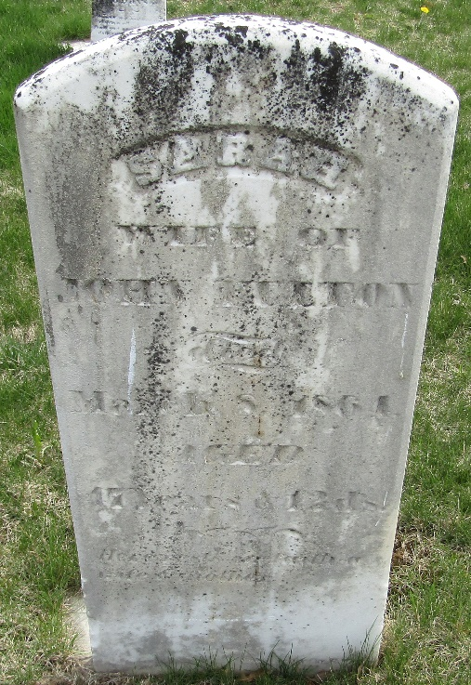

Sarah Egbert from tree Donald Hughes Family Tree
Birth 24 Feb 1817 Ohio, USA
Marriage 2 Oct 1838 Stark, Ohio, USA
Death 8 Mar 1864 Bartholomew, Indiana, USA
Father James F Egbert (1782-1827)
Mother Rachael McMurran (1790-1833)
Spouse John Fulton (1813-1858)

