James T. Fulton
1836 – February 11, 1857

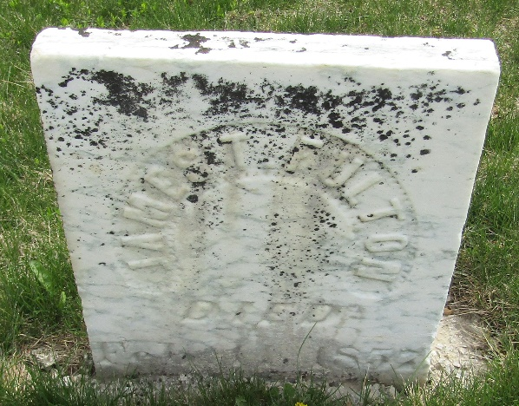

James T Fulton from tree MooreBlakeGantCassaday
Birth 1836 Ohio, USA
Residence 1850 Allen, Indiana, USA
Death 11 Feb 1857
Father Abraham Fulton (1811-1902)
Mother Elizabeth Saylor (1814-1868)

