James Fulton, Sr.
February 23, 1802 – January 16, 1885

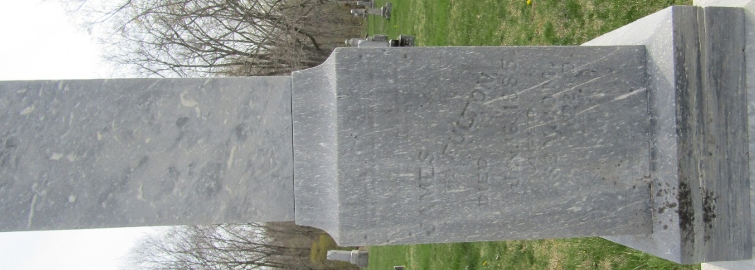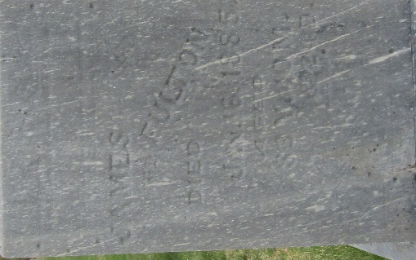

James Fulton from tree New Alexandria & Derry Area
Birth 23 Feb 1802 Westmoreland, Pennsylvania, USA
Death 16 Jan 1885 Wells, Indiana, USA
Father Abraham Fulton (1774-1851)
Mother Anne Smith (1780-1852)
Spouse Margaret B. Mabon (1814-1904)
5196 People 0 Records 0 Sources

