Ann (Smith) Fulton
1780 – December 22, 1852

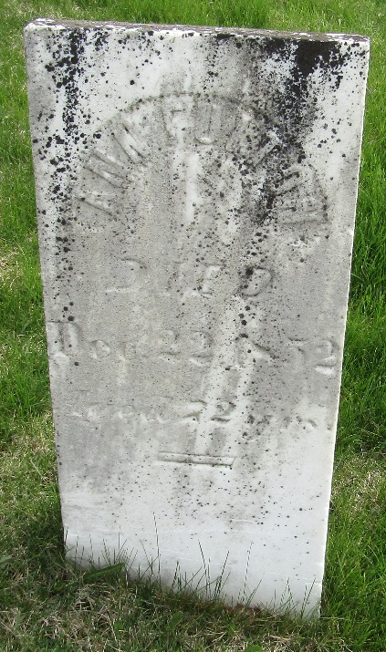

Annie Smith from tree Steve Stapor Family Tree
Birth 1780 Ireland
Death 22 Dec 1852 Wells, Indiana, USA
Spouse Abraham Fulton ` (1773-1853)

