Willard Fryback
April 10, 1889 – September 14, 1913

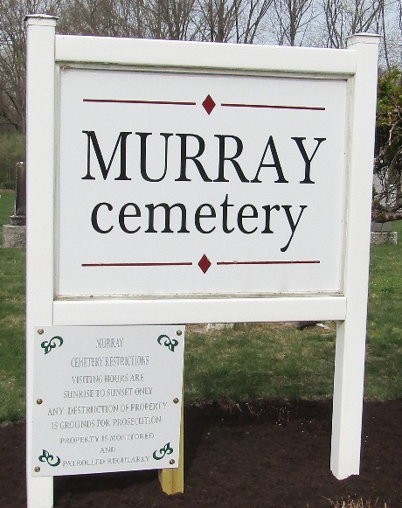

Willard Fryback
in the Indiana, U.S., Death Certificates, 1899-2017
Name Willard Fryback
Gender Male
Race White
Marital Status Married
Age 24
Birth Date 10 Apr 1889
Birth Place Uniondale, Indiana
Death Date 14 Sep 1913
Death Place Fort Wayne, Allen, Indiana, USA
Death Registration Date 1913
Father Frank Fryback
Mother Fannie Bricker
Informant Frank Fryback; Bluffton, Indiana
Burial September 16, 1913; Bluffton, Indiana

