Susannah (Diehm) Fryback
October 31, 1791 – February 8, 1875

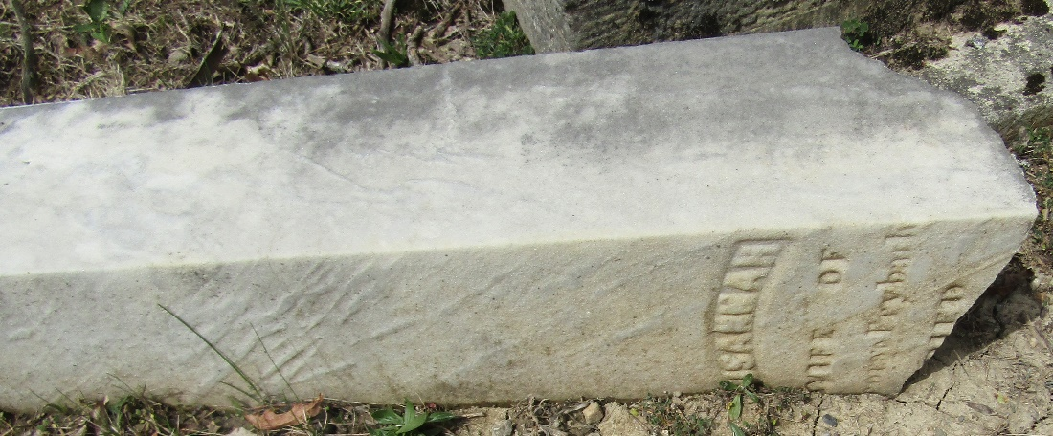

Susannah Deam from tree Austin Family Tree
Birth 31 Oct 1791 Chester, Delaware, Pennsylvania, USA
Marriage 30 Dec 1812 Ohio, USA
Residence 1870 Wells, Indiana, USA
Death 8 Feb 1875 Ossian, Wells, Indiana, USA
Father Heinrich Diehm (1749-1820)
Mother Elizabeth Ache (1772-1825)
Spouse George T. Fryback (1790-1873)

