Sarah S. Fryback
February 19, 1863 – September 17, 1869

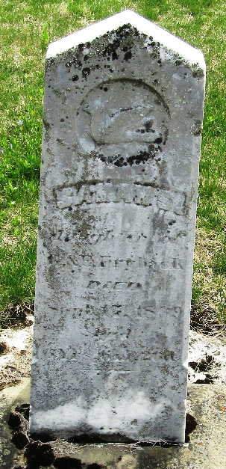

Sarah S. FRYBACK from Aughe Family by Craig
Father George FRYBACK
Mother Eve SCHWARTZ
Birth 19 Feb 1863 Ossian, Wells, Indiana, USA
Death 17 Sep 1869 Ossian, Wells, Indiana, USA

