Sarah Elizabeth (Hart) Fryback
October 10, 1832 – June 25, 1906

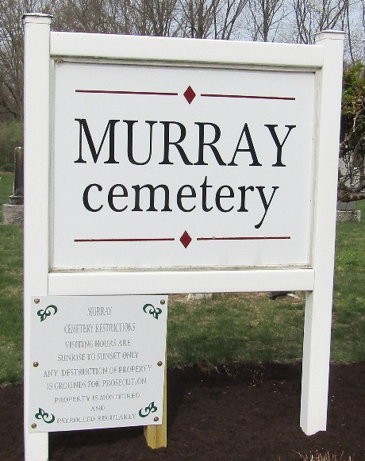

Elizabeth Fryback
in the Indiana, U.S., Death Certificates, 1899-2017
Name Elizabeth Fryback
[Elizabeth Hart]
Gender Female
Race White
Marital Status Widow
Age 74
Birth Date 10 Oct 1832
Birth Place Virginia
Death Date 25 Jun 1906
Death Place Union, Wells, Indiana, USA
Death Registration Date 1906
Father Benj Hart
Mother Elizabeth Geck
Spouse Lewis Fryback
Informant J. N. Fryback; Uniondale, Indiana
Burial June 27, 1906; Murray Cemetery

