Robert N. Fryback
August 21, 1857 – December 9, 1931

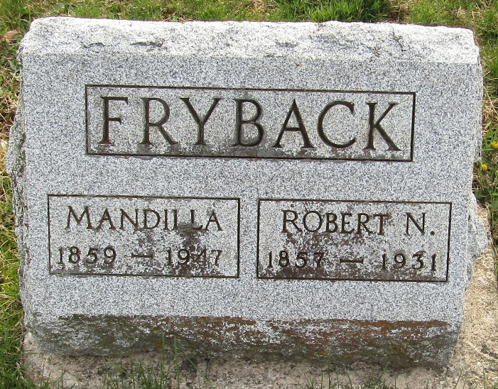

Robert N. Fryback
in the Indiana, U.S., Death Certificates, 1899-2017
Name Robert N. Fryback
Gender Male
Race White
Marital Status Married
Age 74
Birth Date 21 Aug 1857
Birth Place Indiana
Death Date 9 Dec 1931
Death Place Wells, Indiana, USA
Death Registration Date 1931
Father Louis Fryback
Mother Elizabeth Hart
Spouse Mantilla
Informant Charles Porter; Uniondale, Indiana
Burial December 11, 1931; Murray Cemetery

