Mary (Brown) Wysong-Fryback
June 11, 1858 – May 14, 1929

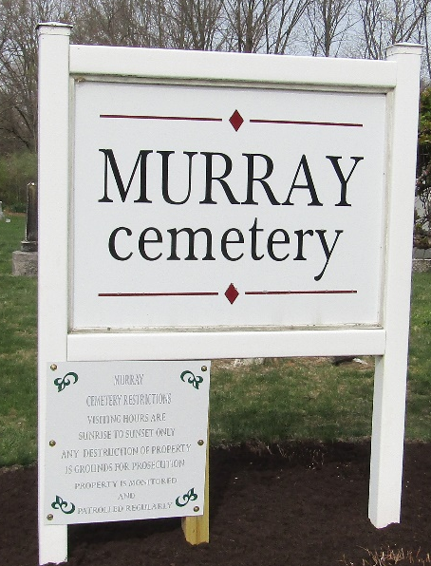

Mary Fryback, 77, died Tuesday morning at the county infirmary following a stroke of paralysis on November 1. She was a daughter of the late John and Elizabeth Weisell Brown.
Her first marriage was to John Wysong and her second marriage was to John Fryback.
Children surviving by her first marriage are: Mrs. Flora Mains, Three Rivers, Michigan; Mrs. Maiza Richards, Fort Wayne; Chester, Bluffton; Emmett, Huntington and Mrs. William Yates, Bluffton.
Funeral services will be held at 2 pm Thursday at the William Yates home. Burial will be at Murray.

Muncie Evening Press, Muncie, Indiana
May 15, 1929

**
Indiana, U.S., Death Certificates, 1899-2017
Name Mary Fryback
[Mary Brown]
Gender Female
Race White
Marital Status Widow
Age 77 years, 11 months
Birth Date Jun 1857
Birth Place Indiana
Death Date 14 May 1929
Death Place Harrison, Wells, Indiana, USA
Death Registration Date 1929
Father John Brown
Mother Elizabeth Weisel
Spouse John Fryback
Informant Mrs. Wm. Yates; Bluffton, Indiana
Burial May 16, 1929; Murray Cemetery

